1. Design DFA using simulator to accept odd number of a’s

INPUT:

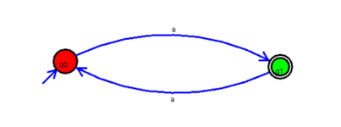

OUTPUT:

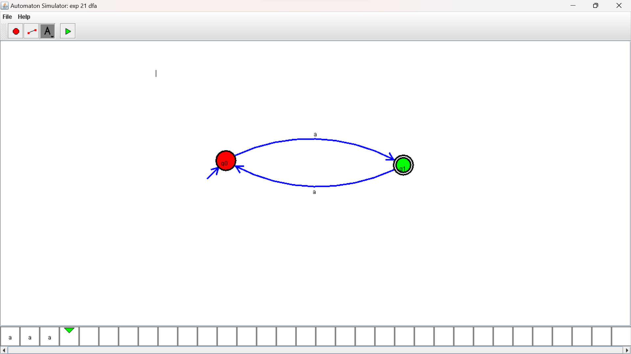

RESULTS:

DFA using simulator to accept odd number of a’s